Place the certificate files into the config software package

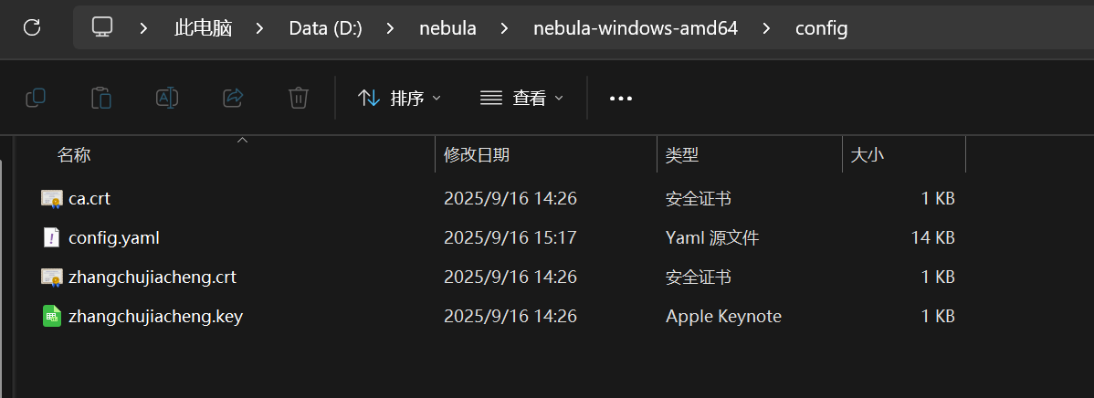

Adjust the configuration file in the following way:

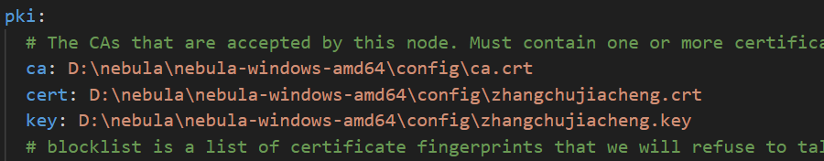

Start the nebula using the administrator command window

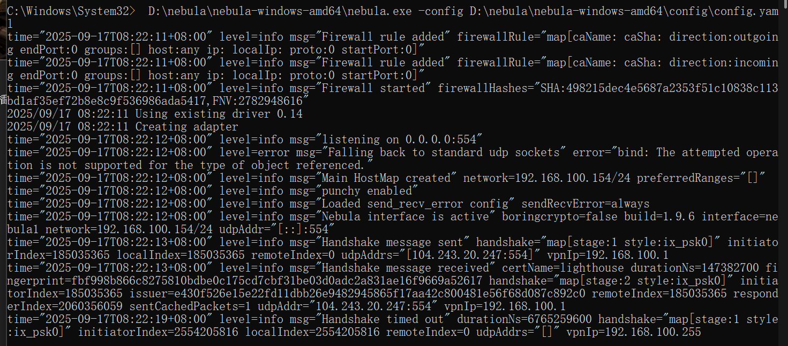

Ping 192.168.100.1

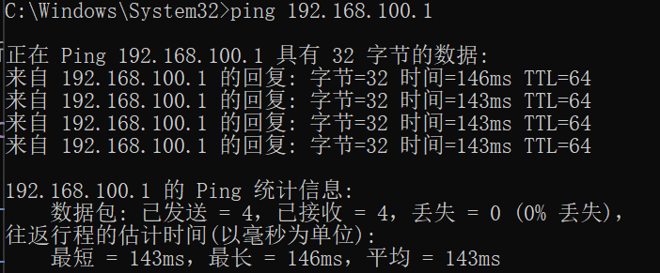

Ssh [nuist@192.168.100.1](mailto:nuist@192.168.100.1) and ping www.goole.com

